|  |  |  |  |  |
| --- | --- | --- | --- | --- |
| **GUJARAT TECHNOLOGICAL UNIVERSITY**  Chandkheda, Ahmedabad  Affiliated | | | | |
| download.jpg | |  | | A._D._Patel_Institute_of_Technology_logo.jpg |
| **A D Patel Institute Of Technology**  **New V V Nagar** | | | | |
| A Project Report  On  **“HOSPITAL SYSTEM”**  Under subject of  DESIGN ENGINEERING-I-A  BE Semester – III  (Electronics and Communication Engineering)  Submitted By:  **Group No:ADEC1818** | | | | |
| **Sr. No** | **Name of Student** | | **Enrollment Number** | |
| 1 | ABHIRAJSINH RAOL | | 180010111018 | |
| 2 | KUSHARAJSINH VAGHELA | | 180010111025 | |
| **Prof. Shailesh Khant**  **Design Project Guide**  **Prof. Shailesh Khant**  **COURSE CO-COORDINATOR**  **Dr H N Patel**  **HEAD OF THE DEPARTMENT**  Academic Year  (2019-20) | | | | |

**ACKNOWLEDGEMENT**

This report is by far the most significant accomplishment in my life and it would be impossible without people who supported me and believed in me. I would like to extend my gratitude and my sincere thanks to my honorable, esteemed supervisor **Prof. Shailesh Khant.** They are not only a great teachers/professors with deep vision but also and most importantly a kind person. I sincerely thank for their exemplary guidance and encouragement. Their trust and support inspired us in the most important moments of making right decisions and I am glad to work with them. My special thanks go to Head of the Department of Electronics and Communication Engineering, A.D.I.T College, New V.V. Nagar, for providing me with best facilities in the Department and his timely suggestions.

I want to thank all my teachers for providing a solid background for my studies and research thereafter. They have been great sources of inspiration to me and I thank them from the bottom of my heart.

I would like to thank all my friends and especially my classmates and my team members for all the thoughtful and mind stimulating discussions we had, which prompted us to think beyond the obvious.

Last but not least I would like to thank my parents, who taught me the value of hard work by their own example. They rendered me enormous support during the whole tenure.

THANK YOU

**ABSTRACT**

In this project we have tried to cover problems faced by patients and doctors in Hospital. They face problems of waiting in registration lines, lack of rooms and beds, lack of upgraded equipments, patients increasing day by day which led us to select and work on this project. Hospital were observed for the advancement in this project. Features of the product were determined considering the various designing aspects. This product has a lot of scope in future applications. This product focuses on the safety of people, life and death risk of people waiting area, launching online registration forms applications, its implementation will be extremely beneficial to the public and to see on a wider prospectus helps in betterment of the economic growth of the country.

**CONTENT**

|  |  |  |
| --- | --- | --- |
| **SR. NO.** | **TOPIC** | **PAGE NO.** |
| **1.** | **Introduction** |  |
| **2.** | AEIOU Frame work |  |
| **3.** | Mind Mapping Technique |  |
| **4.** | Empathy Mapping Canvas |  |
| **5.** | **Ideation Canvas** |  |
| **6.** | **Product Development Canvas** |  |
| **7.** | **Rough Prototype** Model/Conceptual Plan-Layout for process related branches |  |
| **8.** | **Prior art search** |  |
| **9.** | **Conclusion and References** |  |

**Chapter 1: INTRODUCTION**

# TEAM DESCRIPTION:

**Group name**: ADECDE1401

**Branch**: Electronics And Communication

**Group members**:

1. ABHIRAJSINH VAGHELA-180010111018
2. KUSHALRAJSINH VAGHELA-180010111025

**Skills**: Good orative skill, hardworking, adequate time management, decision making, systematic, punctual, good technical skills.

**Mentor**: Prof. Shailesh Khant

Our guide is not only a great teacher/professor with deep vision but also and most importantly a kind person. We sincerely thank for their exemplary guidance and encouragement. Their trust and support inspired us in the most important moments of making right decisions and we are glad to work with them.

# Design thinking is one of the most crucial and important aspect of finding viable solutions to the problems encountered in the society. It consumes the major part of the time as it includes all the factors to be considered in finding the solution.

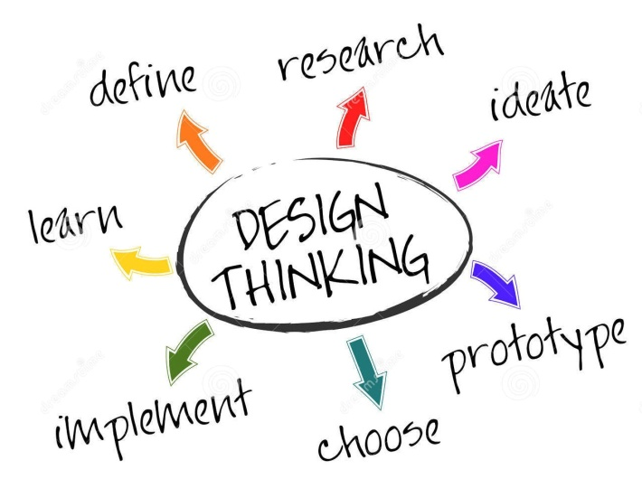

**Design Engineering is a subject that aims** at enhancing the ideas, thinking skills and team work of students. It is more society oriented that will improve the current conditions of livelihood, solve day to day problems etc. Students come up with many ideas during their entire graduation but they are limited by their resources and time. So this subject will include their ideas academically and that will eventually uplift the society.

**Learning Tools:** In this project we have tried to cover problems faced by patients and doctors in Hospital. They face problems of waiting in registration lines, lack of rooms and beds, lack of upgraded equipments, patients increasing day by day which led us to select and work on this project. Hospital were observed for the advancement in this project. Features of the product were determined considering the various designing aspects. This product has a lot of scope in future applications. This product focuses on the safety of people, life and death risk of people waiting area, launching online registration forms applications, its implementation will be extremely beneficial to the public and to see on a wider prospectus helps in betterment of the economic growth of the country.

The use of electronic and communication systems for monitoring and control of agricultural machines, equipment, facilities and processes, and for the management of farms and agricultural companies has played a key role for the achievement of new and better standards in world agriculture.

The advances in electronics have contributed to the great reduction in cost and price of equipment, at the same time that they have increased performance and reliability. A great number of such systems and devices have been proposed for different field operations and parameters.

IDENTIFY NEEDS: “Needs” are human emotional or physical necessities. Needs help define your design challenge. Remember: Needs are verbs (activities and desires with which your user could use help), not nouns (solutions). Identify needs directly out of the user traits you noted, or from contradictions between two traits – such as a disconnect between what she says and what she does. Write down needs on the side of your Empathy Map.

IDENTIFY INSIGHTS: An “Insight” is a remarkable realization that you could leverage to better respond to a design challenge. Insights often grow from contradictions between two user attributes (either within a quadrant or from two different quadrants) or from asking yourself “Why?” when you notice strange behavior. Write down potential insights on the side of your Empathy Map. One way to identify the seeds of insights is to capture “tensions” and “contradictions” as you work.

**Chapter 2: AEIOU Framework**

**2.1 Introduction**

This AEIOU Frame work is interestingly design to describe different design steps which came across during planning of our project work. This framework consists of thinking and observing different activities while doing our survey. This Framework helps in understanding the need of hour, for the completion of our framework we had done a lot of survey where our project can be useful. After doing the appropriate survey we have completed this framework. We have also included the Snapshot of the survey.

**2.2 Activity**

First part of this Framework is Activities, in this part of frame work we have listed the different activities which we had observed at the place of our survey, i.e bus Station.In this Framework we have also listed the different elements, features at that place.

**2.3. Environment**

Second Part of the Framework is Environment Framework , in this Framework we had kept our observation towards atmosphere. It was day or night. In this Framework too we have listed Elements, features.

**2.3. Interaction**

This is Third part of Framework. In this framework we had observed that what kind of interaction were there between the user and the different object.

**2.4. Object**

This is fourth and second last part of the AEIOU framework. This framework relates with the different kind of objects which we had seen at the survey spot.We have also listed the Key objects.

2.5. Users

This is last Part of AEIOU Framework, in this framework we have listed the general impression, pasted the scene of the survey spot or location where no of users are located.

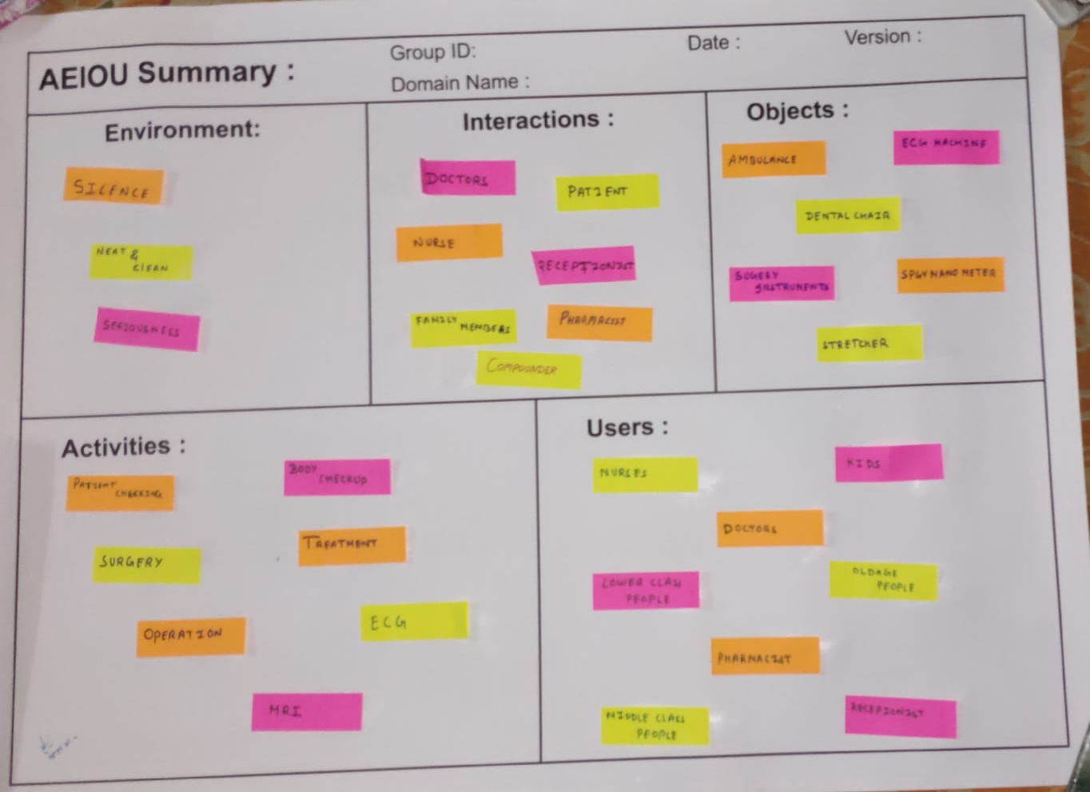

**Chapter 3 MIND MAPPING TECHNIQUE**

We have basically divided our farm into four branches which are specified with a short brief description below:

1. **Environment**: In this part of the mapping we have listed many phases of environment seen in the bus station while I was present and I have observed.

**2. objects:** In this part we have gone through many object which we have found while we were observing the bus station .

1. **Services:** In this part we have gone through certain services provided by the station to the people. The service might be like, water supplies, wheelchair for old aged people etc.

**4. Employ :** There are many people providing services to the people or travellers who come on regular basis.

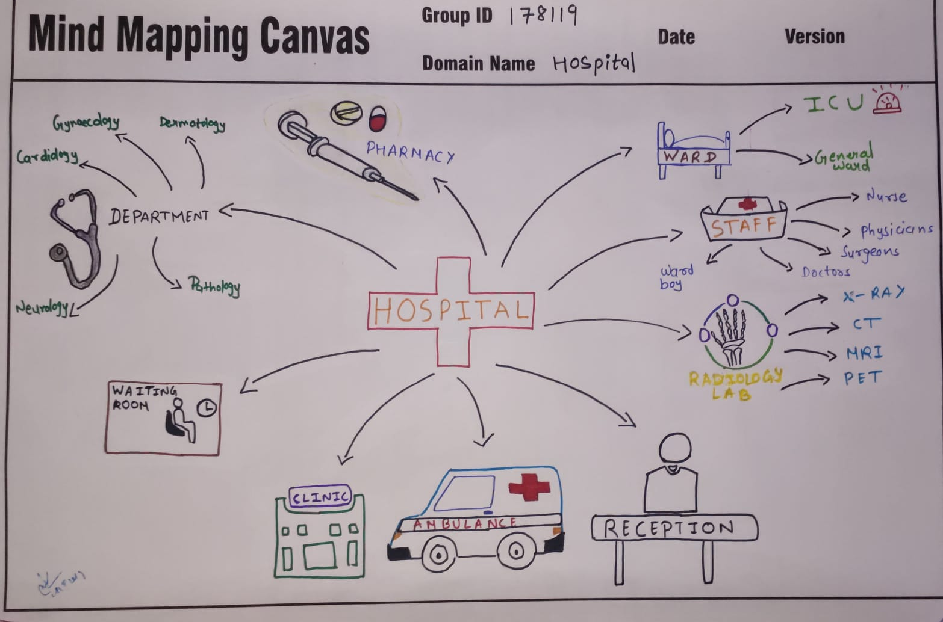

**Chapter 4 Empathy Mapping Canvas**

The Empathy Map is a great powerful tool that helps putting yourself inside the head of a person you might be looking at as a prospective customer or product user. It allows you to quickly grasp their experience and where they are coming from. An empathy map is a collaborative tool teams can use to gain a deeper insight into their customers. Much like a user persona, an empathy map can represent a group of users, such as a customer segment.

An empathy map is a collaborative tool teams can use to gain a deeper insight into their customers. Much like a user persona, an empathy map can represent a group of users, such as a customer segment. The Empathy Map is both a framework and a technique, and it’s typically developed collaboratively by a diverse team by placing sticky notes on a wall. If you’d like to download a template of this poster, you can do so here.

**Developing a deeper understanding of your customers by understanding:**

* ‍Who they are in their world
* Where they spend their time
* Who their friends are
* Whose opinions influence them
* What they SAY their deepest aspirations and beliefs are
* What feelings and beliefs ACTUALLY guide their behavior

1. **User**

* In this stage, we find the various users which are directly or indirectly related to our project.
* for example: Shopping malls, Multiplex, Hospitals, Residential Purpose, Educational Area, Religious Area

1. **Stakeholders**

* Stakeholders mean a person or organization with an interest.
* In this stage, we find the user who will directly or indirectly related to users.
* For example: owner of vehicle

1. **Activities**

* Activities are directly or indirectly related to stakeholders.
* Shopping malls, define parking time, wedding ceremony ,parking rush in religious day

1. **Story Boarding**

* Happy
* Sad
* 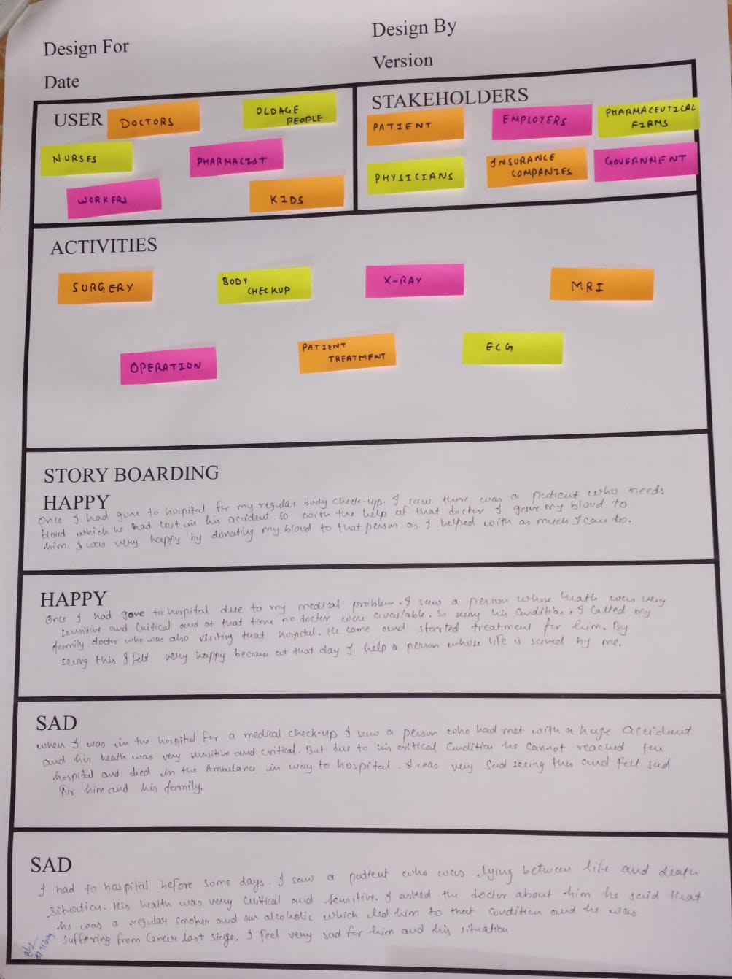

.

**Chapter 5 Ideation Canvas**

These are the second step of the project or problem. From the user canvas, you have an idea what are the people? In ideation canvas, you have to carry out which type of activities is related to your project and people? What is situation and location regarding to activities? Then after you find the possible solutions. It is depend or not depend to your activities**.**

1. **People:** Common public, business class, professional consultations, Government and private staff, educational students and staff
2. **Activities:** Children going to schools, visits/ tours, men/women going to shopping,
3. **Situation/Context/Location:** school in –out time, bicycle/two wheeler, government/private schools, school , festivals, sales, during week end, religious places, Summer / winter vacation
4. **Props/Possible Solutions:**Division of parking space, floor managing in parking lots, green parking, bicycle vertical parking, carpooling, rustication in length of car, hydraulic mechanism.

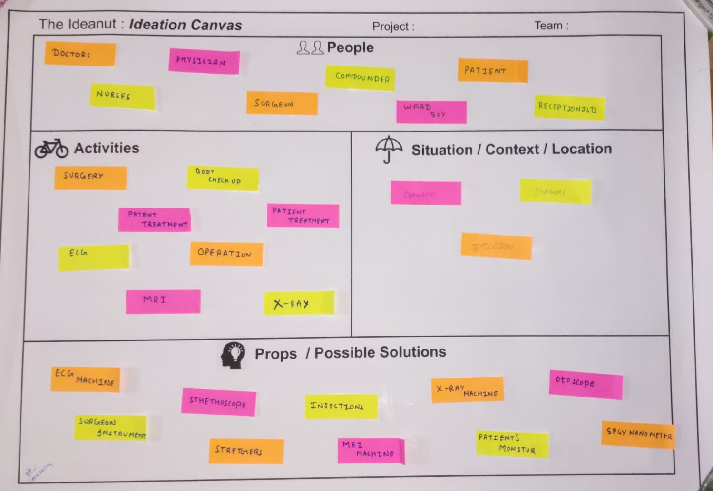

# Chapter 6 Product Development Canvas

**PURPOSE:**

The purpose of our project is to design a handy product that show the timing and route of buses.

* The people can easily come to know that the bus is coming and which route that bus driver is going to take .

**PEOPLE:**

The people to whom our product may be useful is all the people who wants to know about the scedule of the buses.

* Old aged
* Travelers
* Students

**PRODUCT EXPERIENCE:**

* After the introduction of this product, the user will feel relaxed as he will be able to know the timing and route of the buses very easily and there will be no mismatch of the buses.
* As the product is handy, he is not over burdened while using it.

**PRODUCT FUNCTIONS:**

* To display route and timing of buses.
* Also display the delay of buses.

**PRODUCT COMPONENTS:**

* **LED**
* **ARDUINO**
* **TRANSISTORS**
* **COUNTERS**
* **SHIFT REGISTERS**

**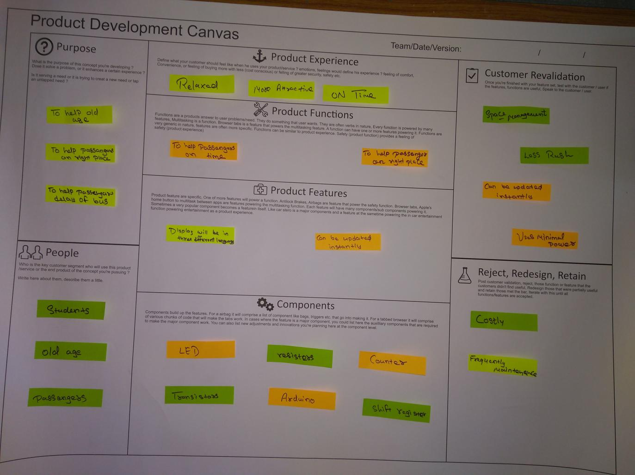**

**Chapter 7 Rough Prototype / Dirty Mock Up**

**(Model/Conceptual Plan-Layout)**

The first draft of prototype/ schematic plan on the product/ concept developed. It shall show the details on anticipated working patterns/ mechanisms or the basic design calculations/ mathematical aspects in the process report, involved in the product development, based on which the first draft of the prototype/ schematic plan has been prepared.

Expressed the concepts/ ideas in a clear and understandable form through description, figures, calculations, drawings and model.

**Chapter 8 Prior Art Search**

**Write related articles from internet , book or research papers**

**Chapter 9 CONCLUSION**

We have concluded that our product which is SET TIMER INJECT DEVICE is going to help the patient to inject the medicines at a preset time when there is no one available which made the patients work very easily .

**10. REFERENCES**

1. **http://gtuinnovationcouncil.ac.in/blog/category/design-engineering/**
2. **http://patents.google.com/**
3. **https://en.wikipedia.org/wiki/Design\_engineer**